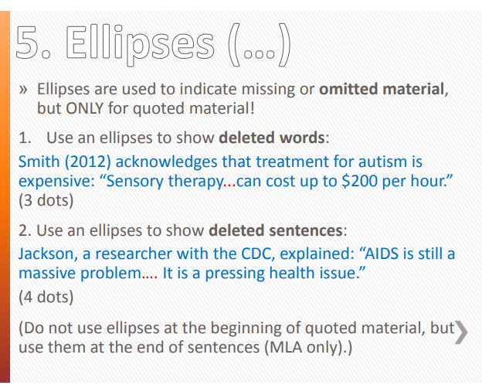

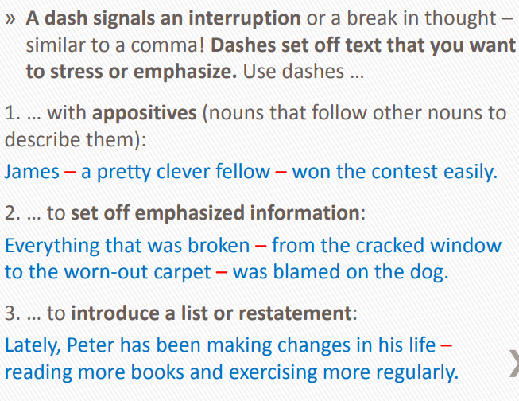
https://ung.edu/writing-center/_uploads/files/gainesville/resources/all-punctuation-powerpoint.pdf

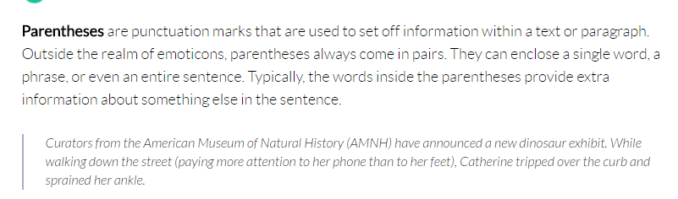
https://www.grammarly.com/blog/parentheses-and-brackets/

