Informational Text Structure

Text structure refers to how the information within a written text is organized. This strategy helps students understand that a text might present a main idea and details; a cause and then its effects; and/or different views of a topic. Teaching students to recognize common text structures can help students monitor their comprehension.
https://www.nsbsd.org/Page/3561
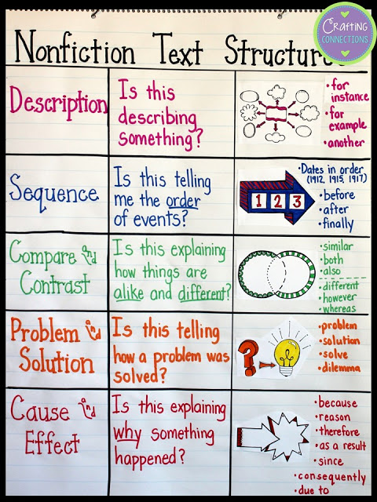
http://crafting-connections.blogspot.com/2016/10/text-structures-lesson-for-upper.html

Great website for learning about text structure: http://www.literacyleader.com/sites/default/files/text%20str%20chart%20w-frames2_0.pdf

“Understanding the expository text structures
gives readers a better shot at determining important information when reading nonfiction...The text in standardized tests and traditional textbooks frequently falls into one or another of these text structures.
If students know what to look for in terms of text structure, they grasp the meaning more easily.”

from Nonfiction Matters, by Stephanie Harvey

Text Structure Examples:

Sequence:

Goose bumps make me shiver. First I get cold. Then I shake
all over.

Description:

Goose bumps make me shiver. I get little bumps on my skin.
They look like sesame seeds.

Compare and Contrast:

Some people get goose bumps from fear. Others get goose
bumps when they are touched emotionally.

Cause and Effect:

Goose bumps make me shiver. When the temperature drops
below 45 degrees, my skin crinkles into goose bumps.

Problem and Solution:

Goose bumps make me shiver. But they disappear as soon as
I cover up with a jacket or sweater.
Now, you try it!

Text Structure Examples:

Sequence:

The first day of school is always an interesting day.

Description:

The first day of school is always an interesting day.

Compare and Contrast:

The first day of school is always an interesting day.

Cause and Effect:

The first day of school is always an interesting day.

Problem and Solution:

The first day of school is always an interesting day.

