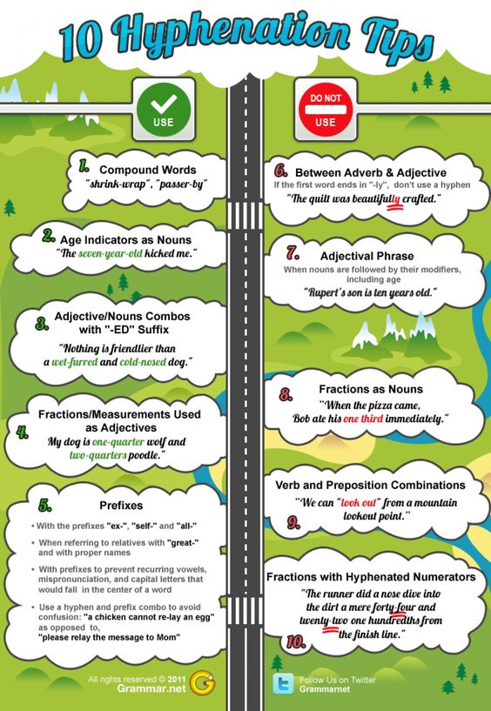
https://visual.ly/community/infographic/education/10-hyphenation-tips?utm_source=visually_embed
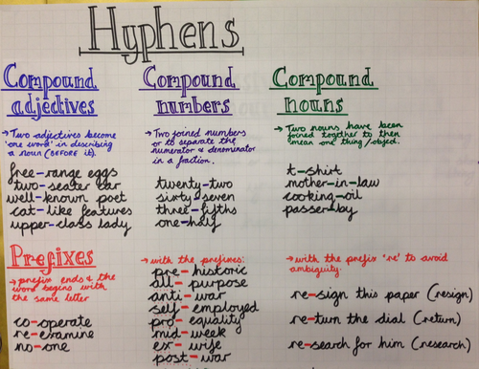
https://www.tes.comhttps://www.tes.com

There are two commandments about this misunderstood punctuation mark. First, hyphens must never be used interchangeably with dashes, which are noticeably longer. Second, there should not be spaces around hyphens.
Incorrect: 300—325 people Incorrect: 300 - 325 people Correct: 300-325 people
Hyphens' main purpose is to glue words together. They notify the reader that two or more elements in a sentence are linked. Although there are rules and customs governing hyphens, there are also situations when writers must decide whether to add them for clarity.
Hyphens Between Words
Rule 1. Generally, hyphenate two or more words when they come before a noun they modify and act as a single idea. This is called a compound adjective.
Examples:
an off-campus apartment
state-of-the-art design
When a compound adjective follows a noun, a hyphen is usually not necessary.
Example: The apartment is off campus.
However, some established compound adjectives are always hyphenated. Double-check with a dictionary or online.
Example: The design is state-of-the-art.
See also Rule 2b in Writing Numbers
Rule 2a. A hyphen is frequently required when forming original compound verbs for vivid writing, humor, or special situations.
Examples:
The slacker video-gamed his way through life.
Queen Victoria throne-sat for six decades.
Rule 2b. When writing out new, original, or unusual compound nouns, writers should hyphenate whenever doing so avoids confusion.
Examples:
I changed my diet and became a no-meater.
No-meater is too confusing without the hyphen.
The slacker was a video gamer.
Video gamer is clear without a hyphen, although some writers might prefer to hyphenate it.
Writers using familiar compound verbs and nouns should consult a dictionary or look online to decide if these verbs and nouns should be hyphenated.
Rule 3. An often overlooked rule for hyphens: The adverb very and adverbs ending in ly are not hyphenated.
Incorrect: the very-elegant watch
Incorrect: the finely-tuned watch
This rule applies only to adverbs. The following two examples are correct because the ly words are not adverbs:
Correct: the friendly-looking dog
Correct: a family-owned cafe
Rule 4. Hyphens are often used to tell the ages of people and things. A handy rule, whether writing about years, months, or any other period of time, is to use hyphens unless the period of time (years, months, weeks, days) is written in plural form:
With hyphens:
We have a two-year-old child.
We have a two-year-old.
No hyphens: The child is two years old. (Because years is plural.)
Exception: The child is one year old. (Or day, week, month, etc.)
Note that when hyphens are involved in expressing ages, two hyphens are required. Many writers forget the second hyphen:
Incorrect: We have a two-year old child.
Without the second hyphen, the sentence is about an "old child."
Rule 5. Never hesitate to add a hyphen if it solves a possible problem. Following are two examples of well-advised hyphens:
Confusing: Springfield has little town charm.
With hyphen: Springfield has little-town charm.
Without the hyphen, the sentence seems to say that Springfield is a dreary place. With the hyphen, little-town becomes a compound adjective, making the writer's intention clear: Springfield is a charming small town.
Confusing: She had a concealed weapons permit.
With hyphen: She had a concealed-weapons permit.
With no hyphen, we can only guess: Was the weapons permit hidden from sight, or was it a permit for concealed weapons? The hyphen makes concealed-weapons a compound adjective, so the reader knows that the writer meant a permit for concealed weapons.
Rule 6. When using numbers, hyphenate spans or estimates of time, distance, or other quantities. Remember not to use spaces around hyphens.
Examples:
3:15-3:45 p.m.
1999-2016
300-325 people
Note: Most publishers use the slightly longer en dash instead of a hyphen in this situation.
Examples:
3:15–3:45 p.m.
1999–2016
300–325 people
Here is how to type an en dash: On a PC, hold down the ALT key and type 0150 on the numeric keypad located on the far right of the keyboard. On a Mac, hold down the Option key and type the minus sign located at the top of the keyboard.
Rule 7. Hyphenate all compound numbers from twenty-one through ninety-nine.
Examples:
thirty-two children
one thousand two hundred twenty-one dollars
Rule 8a. Hyphenate all spelled-out fractions. But do not hyphenate fractions introduced with a or an.
Examples:
More than one-third of registered voters oppose the measure.
More than a third of registered voters oppose the measure.
Rule 8b. When writing out numbers with fractions, hyphenate only the fractions unless the construction is a compound adjective.
Correct: The sign is five and one-half feet long.
Correct: A five-and-one-half-foot-long sign.
Incorrect: The sign is five-and-one-half feet long.
Rule 9a. Do not hyphenate proper nouns of more than one word when they are used as compound adjectives.
Incorrect: She is an Academy-Award nominee.
Correct: She is an Academy Award nominee.
Rule 9b. However, hyphenate most double last names.
Example: Sir Winthrop Heinz-Eakins will attend.
Rule 10. Many editors do not hyphenate certain well-known expressions. They believe that set phrases, because of their familiarity (e.g., high school, ice cream, twentieth century), can go before a noun without risk of confusing the reader.
Examples:
a high school senior
an ice cream cone
a twentieth century throwback
However, other editors prefer hyphenating all compound modifiers, even those with low risk of ambiguity.
Examples:
a high-school senior
an ice-cream cone
a twentieth-century throwback
Rule 11. When in doubt, look it up. Some familiar phrases may require hyphens. For instance, is a book up to date or up-to-date? Don't guess; have a dictionary close by, or look it up online.

Hyphens with Prefixes and Suffixes
A prefix (a, un, de, ab, sub, post, anti, etc.) is a letter or set of letters placed before a root word. The word prefixitself contains the prefix pre. Prefixes expand or change a word's meaning, sometimes radically: the prefixes a, un, and dis, for example, change words into their opposites (e.g., political, apolitical; friendly, unfriendly; honor, dishonor).
Rule 1. Hyphenate prefixes when they come before proper nouns or proper adjectives.
Examples:
trans-American
mid-July
Rule 2. In describing family relations, great requires a hyphen, but grand becomes part of the word without a hyphen.
Examples:
My grandson and my granduncle never met.
My great-great-grandfather fought in the Civil War.
Do not hyphenate half brother or half sister.
Rule 3. For clarity, many writers hyphenate prefixes ending in a vowel when the root word begins with the same letter.
Example:
ultra-ambitious
semi-invalid
re-elect
Rule 4. Hyphenate all words beginning with the prefixes self-, ex- (i.e., former), and all-.
Examples:
self-assured
ex-mayor
all-knowing
Rule 5. Use a hyphen with the prefix re when omitting the hyphen would cause confusion with another word.
Examples:
Will she recover from her illness?
I have re-covered the sofa twice.
Omitting the hyphen would cause confusion with recover.
I must re-press the shirt.
Omitting the hyphen would cause confusion with repress.
The stamps have been reissued.
A hyphen after re- is not needed because there is no confusion with another word.
Rule 6. Writers often hyphenate prefixes when they feel a word might be distracting or confusing without the hyphen.
Examples:
de-ice
With no hyphen we get deice, which might stump readers.
co-worker
With no hyphen we get coworker, which could be distracting because it starts with cow.
A suffix (y, er, ism, able, etc.) is a letter or set of letters that follows a root word. Suffixes form new words or alter the original word to perform a different task. For example, the noun scandal can be made into the adjective scandalous by adding the suffix ous. It becomes the verb scandalize by adding the suffix ize.
Rule 1. Suffixes are not usually hyphenated. Some exceptions: -style, -elect, -free, -based.
Examples:
Modernist-style paintings
Mayor-elect Smith
sugar-free soda
oil-based sludge
Rule 2. For clarity, writers often hyphenate when the last letter in the root word is the same as the first letter in the suffix.
Examples:
graffiti-ism
wiretap-proof
Rule 3. Use discretion—and sometimes a dictionary—before deciding to place a hyphen before a suffix. But do not hesitate to hyphenate a rare usage if it avoids confusion.
Examples:
the annual dance-athon
an eel-esque sea creature
Although the preceding hyphens help clarify unusual terms, they are optional and might not be every writer's choice. Still, many readers would scratch their heads for a moment over danceathon and eelesque.

