How to Annotate Text
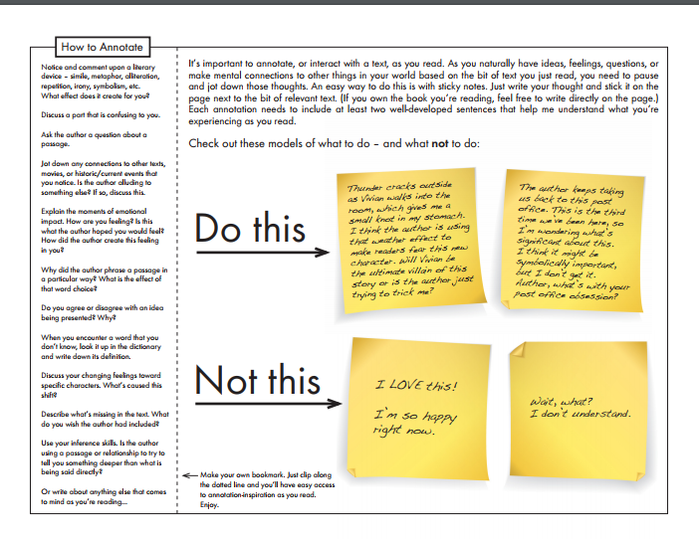https://www.teacherspayteachers.com/Store/Laura-Randazzo?aref=udlsj0ki

