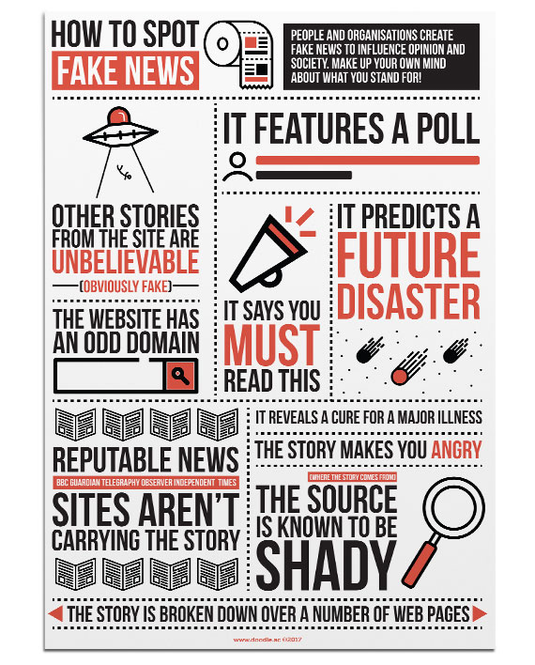
www.doodle.com
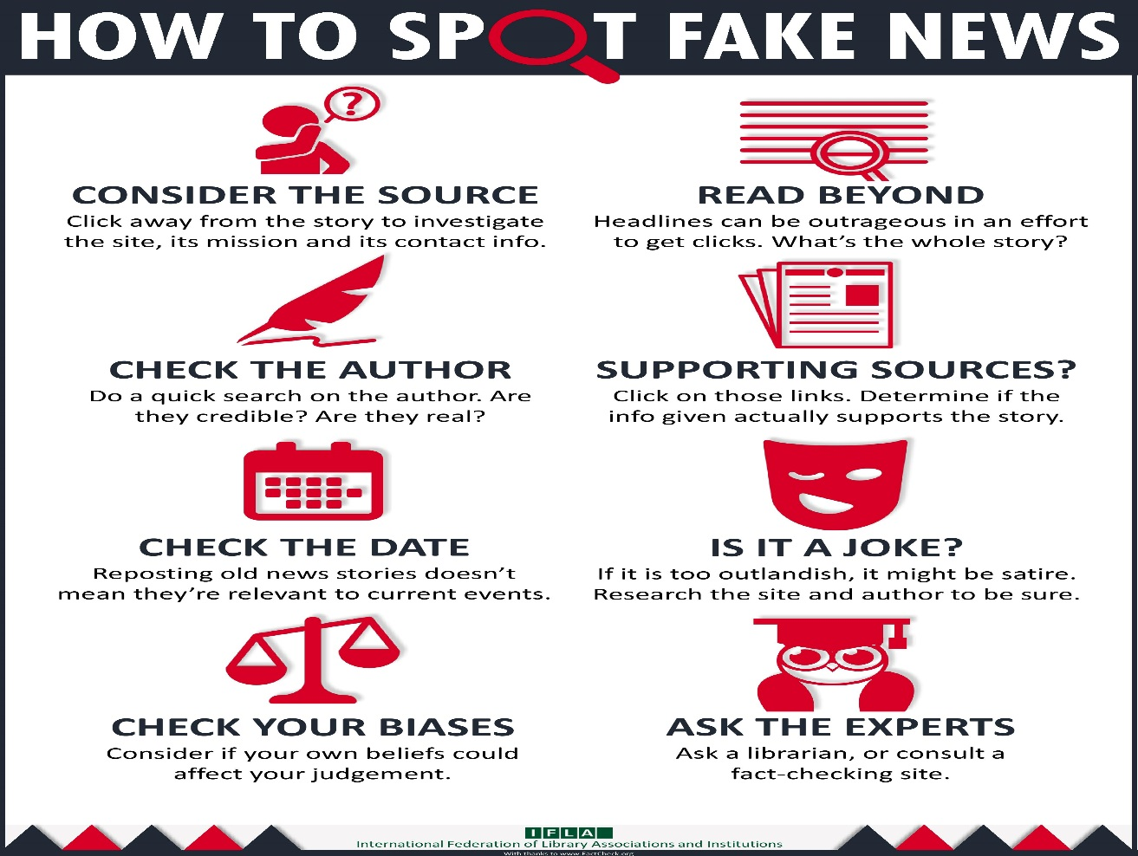

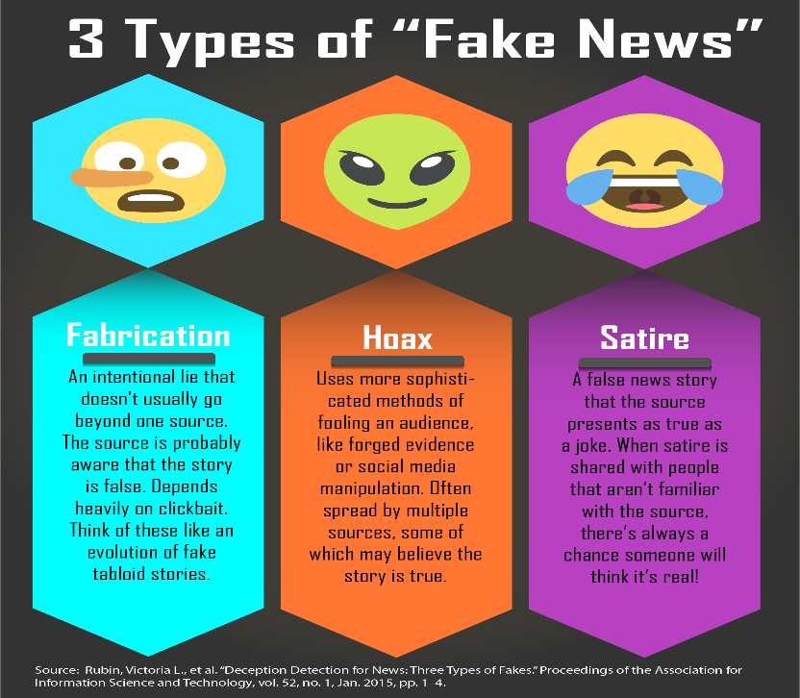
http://guides.zsr.wfu.edu/fakenews
FAKE NEWS
Information can be dubious for all kinds of reasons besides outright deception. The following terms cover some other things to be wary of as you read the news.
Advertisement - Information that is sponsored by a person or organization to promote a brand or product. The conflict of interest created by paying for the presentation of the information means that ads are not reliable sources of factual information.
Astroturfing - The practice of disguising the source of information in order to give the impression that it has more popular support than it may have in reality. The term comes from the brand name of an artificial grass, playing on the idea that it is faking "grassroots" support.
Bias - An inclination or tendency, used especially when it leads to unfair or unreasonable treatment. There are all kinds of biases, including bias for or against a political affiliation, nation, race, gender, class, or many other things. Having a bias doesn't necessarily mean someone is trying to deceive you, but it can cause them to ignore information that disagrees with their perspective.
Clickbait - Something (usually a headline) that is intended to lure you into clicking on a link that would otherwise be uninteresting. Clickbait isn't necessarily deceitful, but it can often result in outrageous or upsetting headlines that aren't backed up in the article.
Conspiracy Theory - A pattern of thinking that holds that the truth about a situation is being suppressed by powerful people. Deceitful sources often use conspiracy theory to cultivate the false idea that any source that disagrees with them can't be trusted.
Junk Science - Information that appears to be justified scientifically (with data, theoretical frameworks, etc.) that, whether because of bad methodology or intentional fraud, is actually inaccurate.
Propaganda - Information that is promoted specifically to advance or hinder a cause or organization, used especially in the context of nations or ideologies. Propaganda might be factually correct or incorrect, but it is biased by definition and therefore not a reliable source of factual information.
Rumor - Unverified information that is spread on the assumption that it may be true. Many sources specialize in reporting on rumors, but one should always wait for confirmation from authoritative sources before treating this kind of information as fact.
Scam - An act in which one uses fraudulent information to profit somehow from victims that believe the information is true. Scams might not be "fake news" themselves, but fake news can often be used to support a scam.

https://libguides.com.edu/c.php?g=649912&p=4556567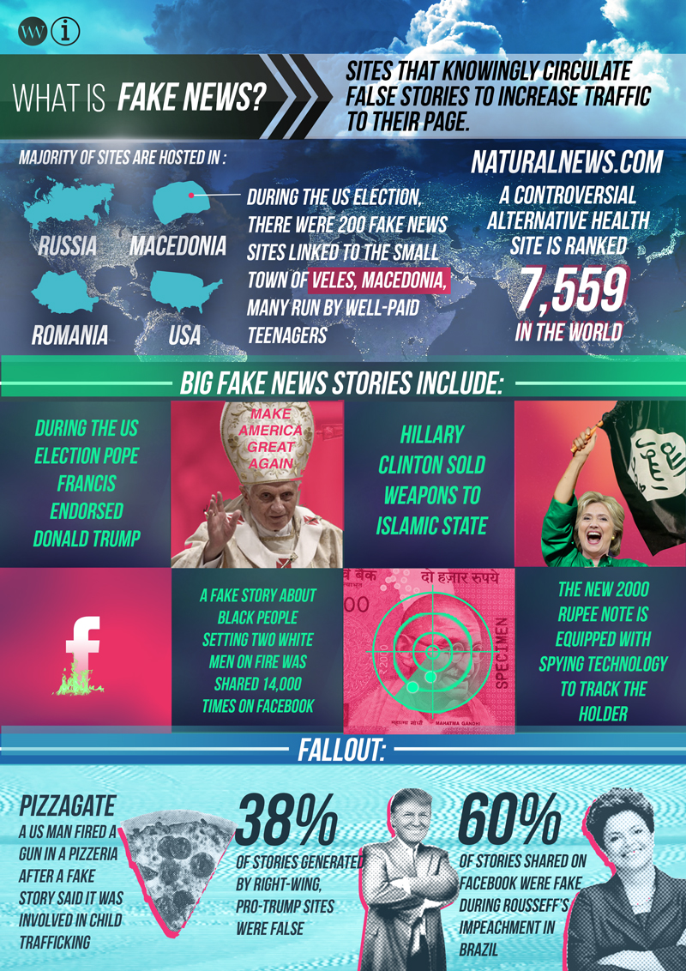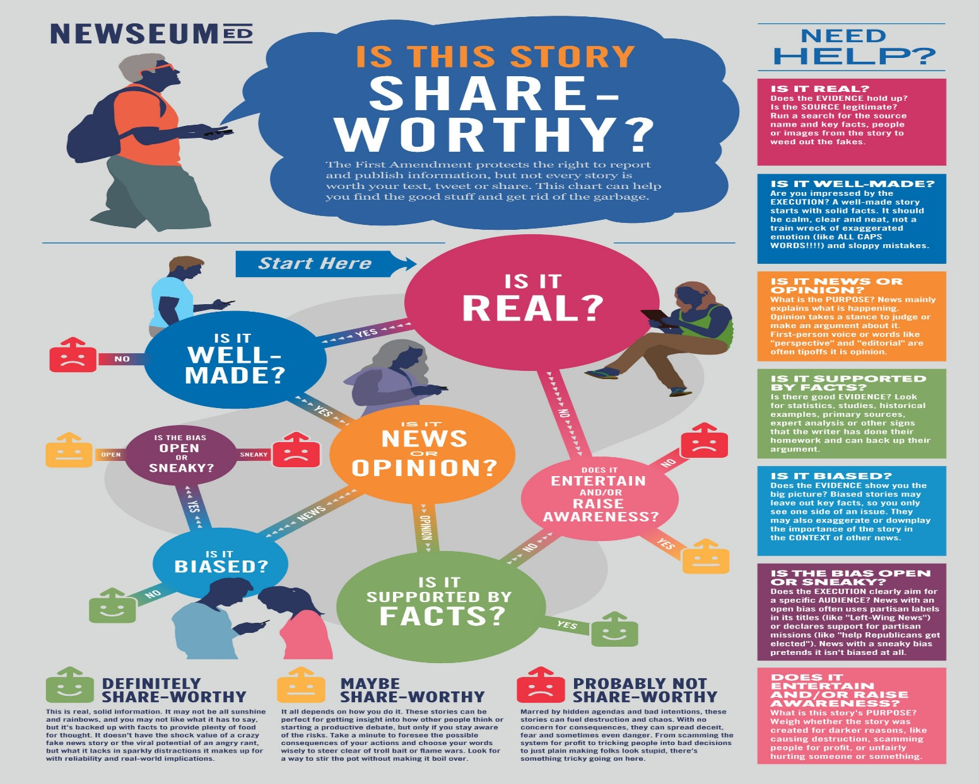

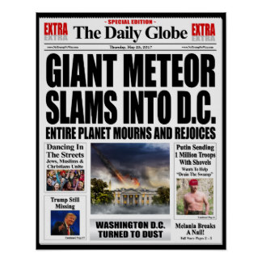
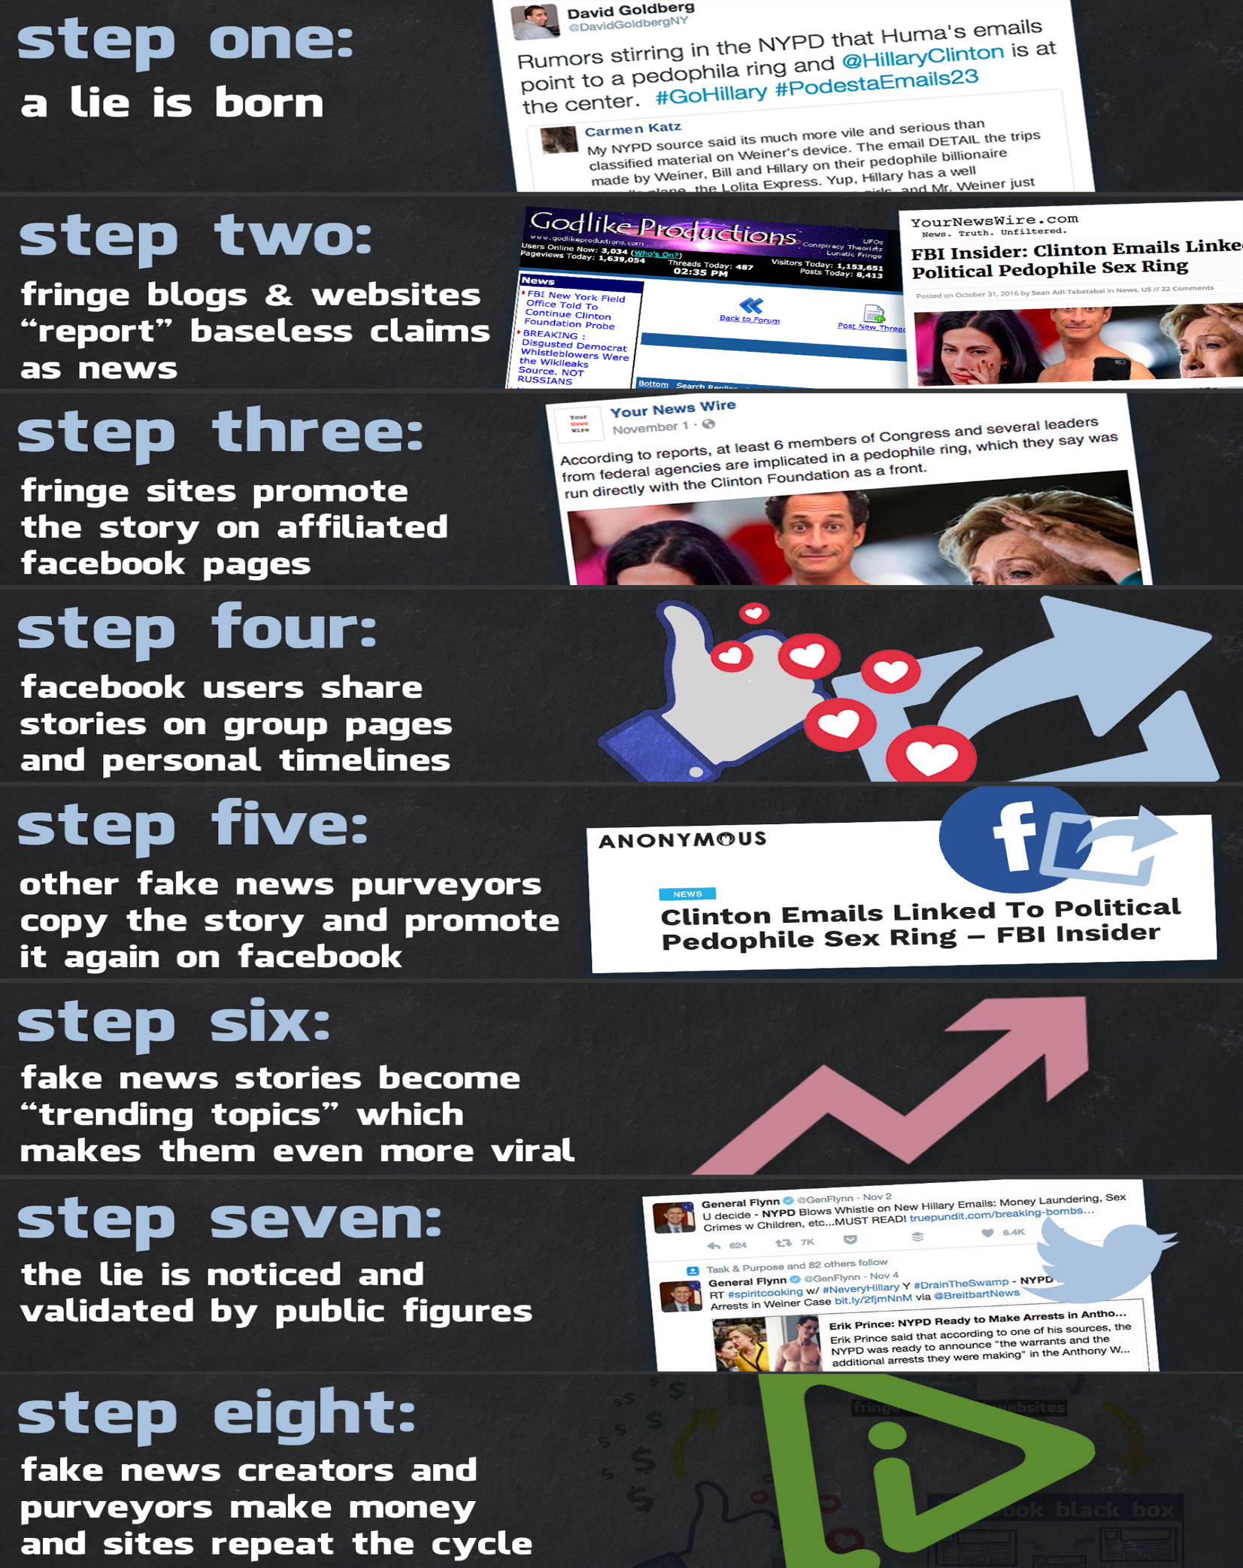
https://www.mediamatters.org/blog/2016/12/21/how-facebook-s-fake-news-ecosystem-empowers-total-lies/214860

