- Go to the following website: http://www.gaexperienceonline.com/
- Click on the following green link: 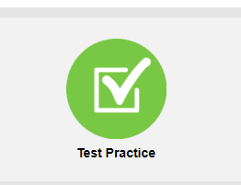

- Click on the following link: 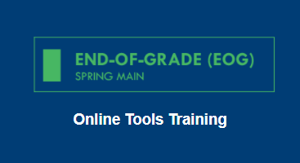

- Click the Grades 6-8 button: 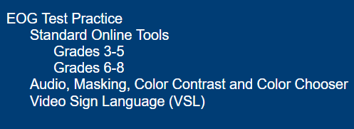

- Enter the Username and Password provided: 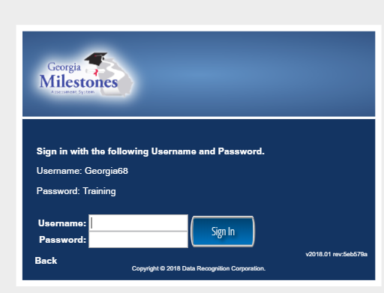 The test should now appear.

