Dialogue and Descriptive Writing
Videos about Dialogue:
Dialogue: https://www.youtube.com/watch?v=ie2KFXkpb4M
Dialogue Prezi: https://prezi.com/goo1ulc6zzf5/analyzing-dialogue/
Using Dialogue: https://www.youtube.com/watch?v=ie2KFXkpb4M

Videos about Writing Descriptively:
Writing Descriptively: https://www.youtube.com/watch?v=RSoRzTtwgP4

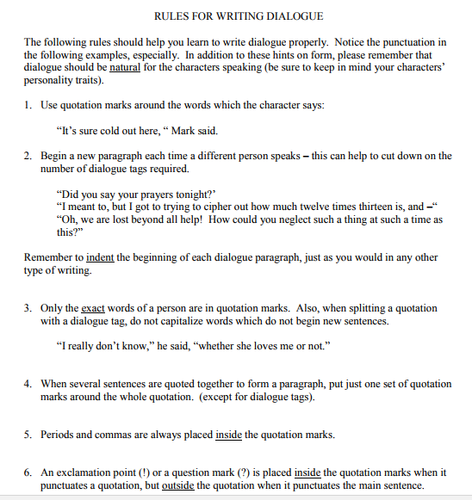

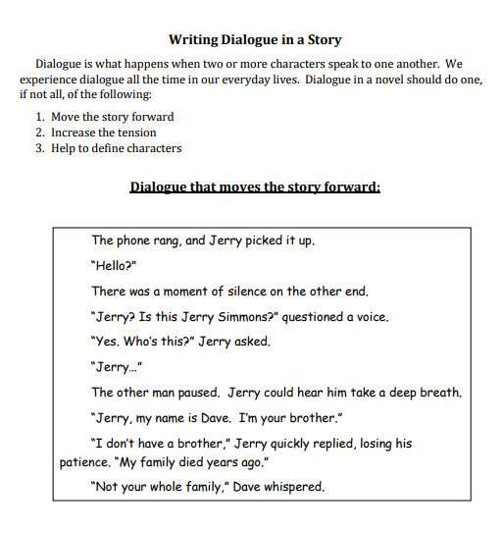
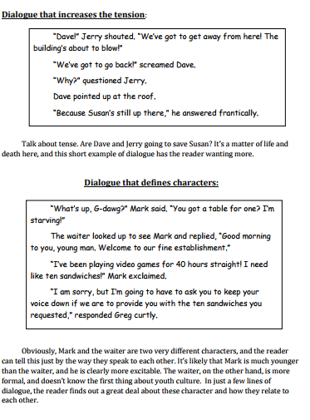
Source: https://www.lcps.org/cms/lib4/VA01000195/Centricity/Domain/2690/Dialogue%20Conversation%202016.pdf

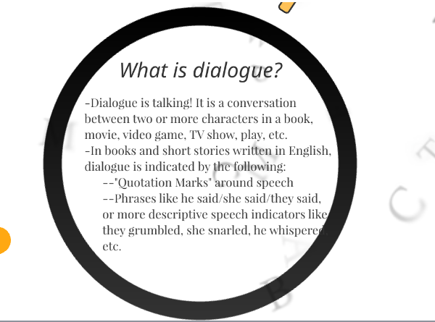
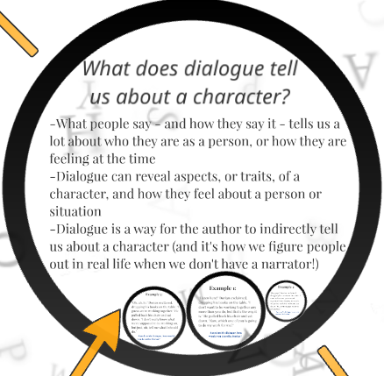
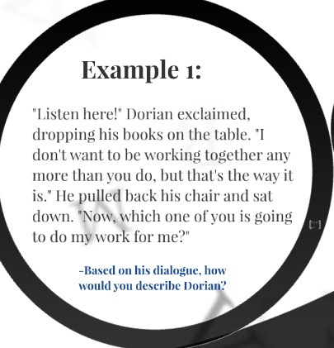
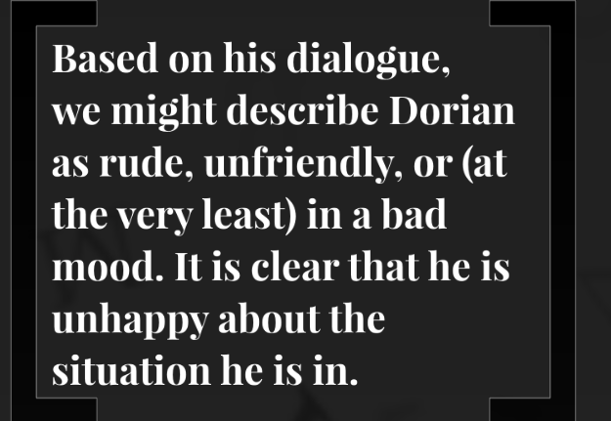
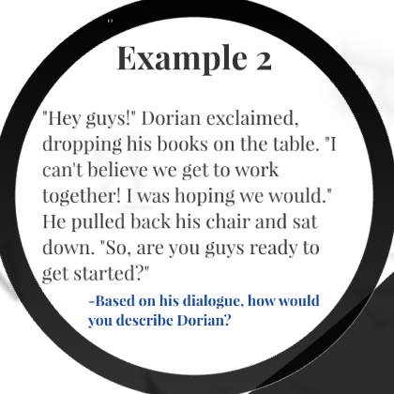
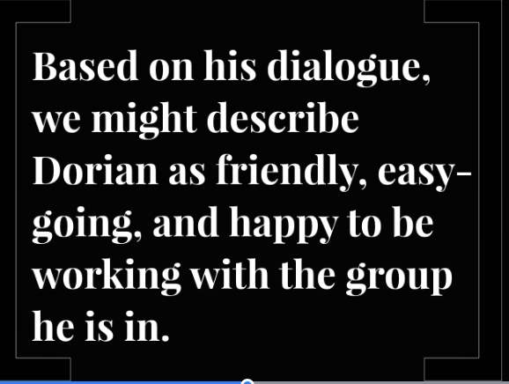
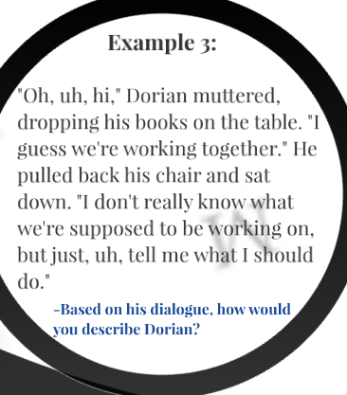
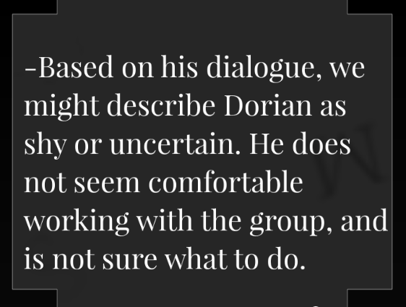

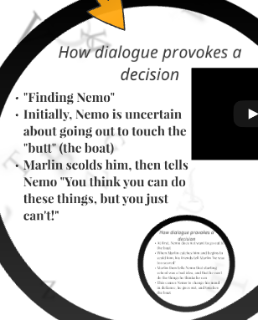

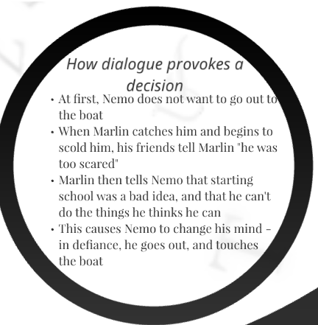
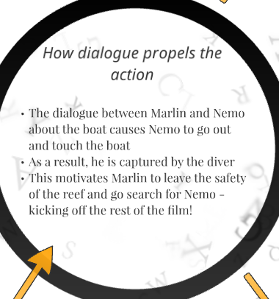

Source: https://prezi.com/goo1ulc6zzf5/analyzing-dialogue/

