Dates: January 22-26, 2018 |  |  | Lesson Focus: Media Truth / Fake News
Standard(s):
ELAGSE8RI1: Cite the textual evidence that most strongly supports an analysis of what the text says explicitly as well as inferences drawn from the text.
ELAGSE8RI5: Analyze in detail the structure of a specific paragraph in a text, including the role of particular sentences in developing and refining a key concept.
ELAGSE8RI6: Determine an author’s point of view or purpose in a text and analyze how the author acknowledges and responds to conflicting evidence or viewpoints.
Essential Question(s): How can a biased news report affect our perspectives? How does objectivity play into author’s purpose? How can you decide if news is reliable? What is the best piece of evidence to support reliable news? How does theme develop?
Objective: SWBAT cite evidence to support reliable news, determined biased news, analyze biased news and engage in collaborative discussion.
Learning Target(s)/”I CAN” Statement(s):
SWKHT cite textual evidence.  SWKHT determine biased news reports.  SWKHT analyze bias new reports and determine their effects on perspective.  SWKHT objectivity plays into author’s purpose.  SWKHT determine theme.  SWKHT engage in collaborative discussions. | SWBAT cite evidence that most strongly supports reliable news.  SWBAT determine what is a biased news report.  SWBAT analyze bias news reports to see how they affect our perspective.  SWBAT determine and analyze how objectivity plays into author’s purpose.  SWBAT determine and then engage in collaborative discussions about how theme develops.
Academic Vocabulary: Explicit/ Implicit/ Bias, Objective / Subjective, Evidence, Point of View, Counterclaim, Spin, Bandwagon
Monday 22 | Tuesday 23 | Wednesday 24 |  | Thursday 25 | Friday 26
1.What is accountable talk (protocol for discussions) and how do we participate in accountable talk?  **Accountable Talk  2. Video on Thinking Notes  https://www.teachingchannel.org/videos/student-annotated-reading-strategy  3. Literature Circles applying accountable talk. | 1.Define author’s purpose fake news, bias, spin, objective, and subjective.  2. Hyphen Rules.  3. Review R.A.C.E | 1.Show Videos and Ted Talk for fake news:  https://newseumed.org/artifact/video-explores-what-fake-news-is-and-isnt/?form_id=12  https://newseumed.org/activity/fake-news-whats-the-big-deal-mlbp/  "How Fake News Does Real Harm"  2. Read article, "Real News Reports..." and annotate for evidence for spotting the truth in media, media bias, and objectivity and subjectivity. “How do we decide if news is truthful and reliable?” |  | 1.Vocabulary and Hyphens Quiz on Thursday. (Open Notes)  2. Design a flyer/poster or cube that will be about the dangers of fake news and how to spot fake news.  Due Friday February 2, 2018. |  | 1.Formative Assessment: Use evidence from article and TED/Video resources R.A.C.E constructed response prompt: “How do we decide if news is truthful and reliable?  2. Homework Due  answer questions for Danger of a Single Story and The Tell Tale Heart.
I will apply as much time as possible to:
MAP Elements:
Allusion Inferences
Conflicting Ideas Point of View Satire Conflict Why vocab. Is most likely used
Text Structure Main Idea
Best describes passage as a whole Drawback
Character Traits
Characterization 5 Senses
EOY Testing Elements: Explain test format, narrative techniques alternative endings, review a portion from different point of view, maintain POV change ending, apply RACE or PEEL, paired passages for argumentative writing, pacing of test, quotation marks, conventions, dialogue between two characters reveals a scene, Informational writing
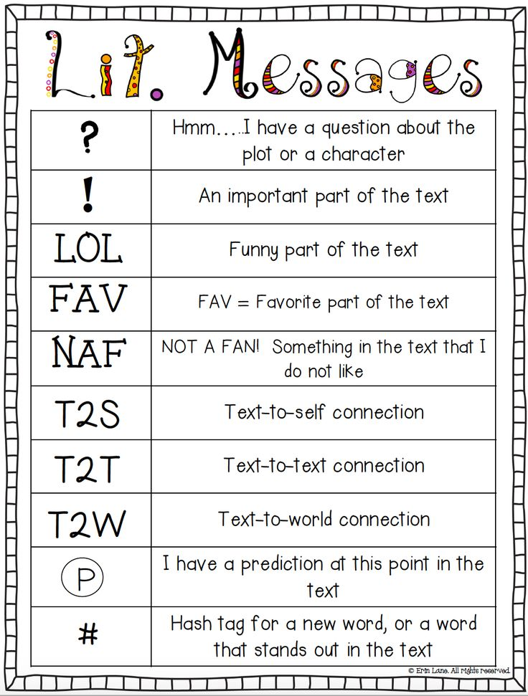  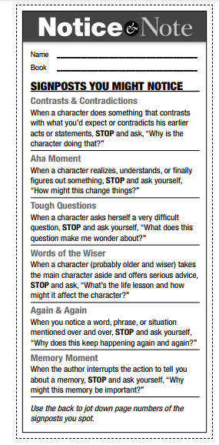 | 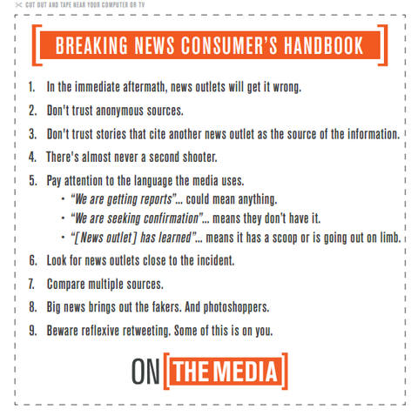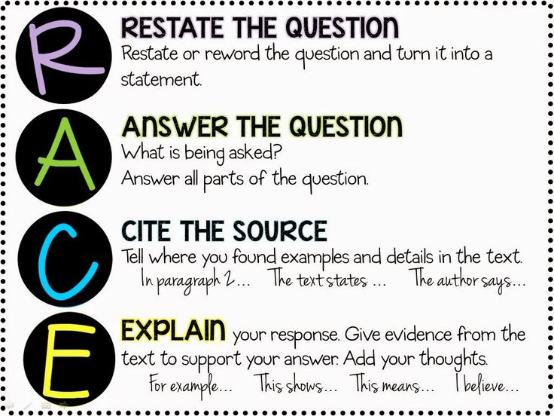  The Consumer’s Questions  WHO made this?  - Professional journalists?  - Citizen journalists?  - Average Joes?  - Qualified experts?  WHY was this made? What is its purpose?  - To inform?  - To get my attention?  - To make money?  - To persuade/change minds?  HOW is the information sourced?  - Primary or secondary?  - Named and/or anonymous?  - Print, digital or social media?  WHEN was this made?  - Is it current? Does it have any outdated information or links?  - Has enough time passed to verify the facts?  WHAT is this missing?  - Is this the whole story?  - What perspectives aren’t represented?  - What questions aren’t answered?  WHERE do I go from here?  - How do I get additional information? Verify the facts?  - Where can I find other perspectives on the topic?  - Remember: Many is better than few.  https://newseumed.org/?s=fake+news

